Project Design Phase-II
Technology Stack (Architecture & Stack)

Date | 03 July 2026
Team ID
Project Name | Cab Booking Platform
Maximum Marks | 4 Marks

Technical Architecture:
The Deliverable shall include the architectural diagram as below and the information as per the table1 & table 2
Cab Booking Platform — Architecture Diagram
Note: Diagram generated based on the actual project repository — https://github.com/Mahathikuruba/CabBooking

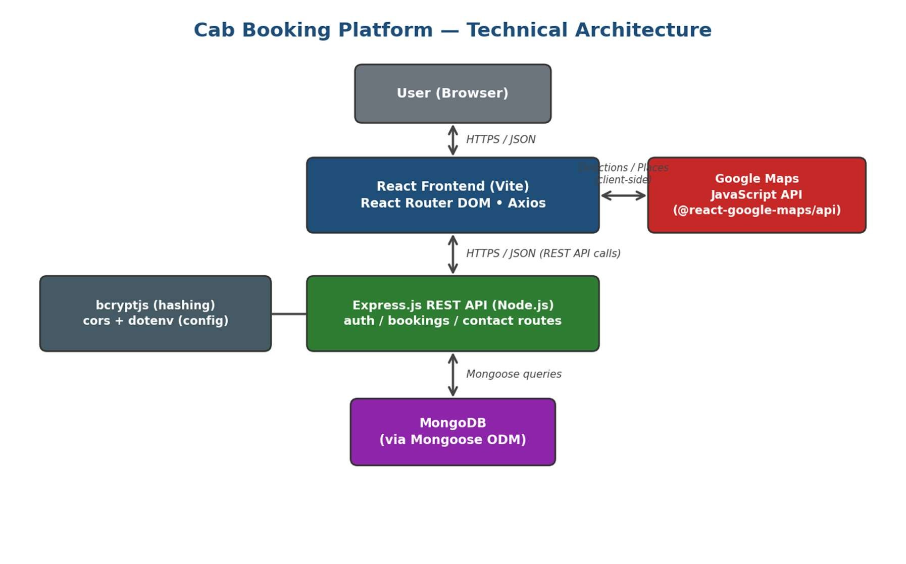

Table-1 : Components & Technologies:

S.N  o | Component | Description | Technology
1. | User Interface | Web UI built with React — pages for Register, Login, Home, Book a Cab, Booking History, About and Contact. | React JS 19 (Vite), React  Router DOM, HTML, CSS,  JavaScript
2. | Application Logic-1 | User registration & login logic — validates credentials and verifies hashed passwords. | Node.js + Express.js  (authController.js), bcryptjs
3. | Application Logic-2 | Cab booking logic — create, update and cancel bookings; autoassigns a driver; stores fare, distance and duration. | Node.js + Express.js  (bookingController.js)
4. | Application Logic-3 | Contact Us logic — stores visitor name, email and message submitted from the Contact page. | Node.js + Express.js  (contactController.js)
5. | Database | Stores users, bookings and contact messages. | MongoDB (NoSQL) via  Mongoose ODM
6. | External API-1 | External API used to plot pickup/drop locations and calculate route, distance & duration. | Google Maps JavaScript API (@react-googlemaps/api)
7. | Infrastructure (Server /  Cloud) | Application deployed on local system for development. Local Server Configuration:  Node.js/Express backend (via nodemon) + Vite dev server for the React frontend. Cloud Server  Configuration: not yet deployed. | Local development setup (no cloud deployment configured yet)

Table-2: Application Characteristics:

S.No | Characteristics | Description | Technology
1. | Open-Source  Frameworks | Open-source frameworks and libraries used to build the application. | React, React Router DOM,  Express.js, Mongoose, Axios  (all open-source)
2. | Security  Implementations | Security / access controls implemented in the current version. | Password hashing with bcryptjs; CORS enabled on  the API; secrets  (MONGO_URI, PORT)  managed via dotenv. Note: jsonwebtoken is listed as a dependency but token-based auth is not yet wired into the login flow.
3. | Scalable  Architecture | Justification for scalability of the architecture. | 2-tier client-server design — a stateless Express REST API decoupled from the React frontend, allowing frontend and backend to scale independently
4. | Availability | Justification for availability of the application. | Runs as a single Node.js server instance for  development; no load balancer or replica set configured yet  (planned for future deployment)
5. | Performance | Design considerations for performance. | Vite dev server for fast builds/HMR; lightweight JSON responses via Axios; Google Maps calls made on-demand only during booking

References:
https://c4model.com/ https://developer.ibm.com/patterns/online-order-processing-system-during-pandemic/ https://www.ibm.com/cloud/architecture https://aws.amazon.com/architecture
https://medium.com/the-internal-startup/how-to-draw-useful-technical-architecturediagrams-2d20c9fda90d

